# CE29x Team MVP Report

Team Number: 5

Module Code: CE291  
  
CSEEGit URL: [*https://github.com/benleong94/pmchallenge*](https://github.com/benleong94/pmchallenge)

CSEEJira Project URL: [*https://bendemeerben.atlassian.net/jira/software/projects/SS/boards/4*](https://bendemeerben.atlassian.net/jira/software/projects/SS/boards/4)

Team Members:

* *Chio Yong Kiong*
* *Kong Chee Wee*
* *Benjamin Leong Jia Juin*
* *Nelson Tan Chun Soon*

# MVP Product Demonstration

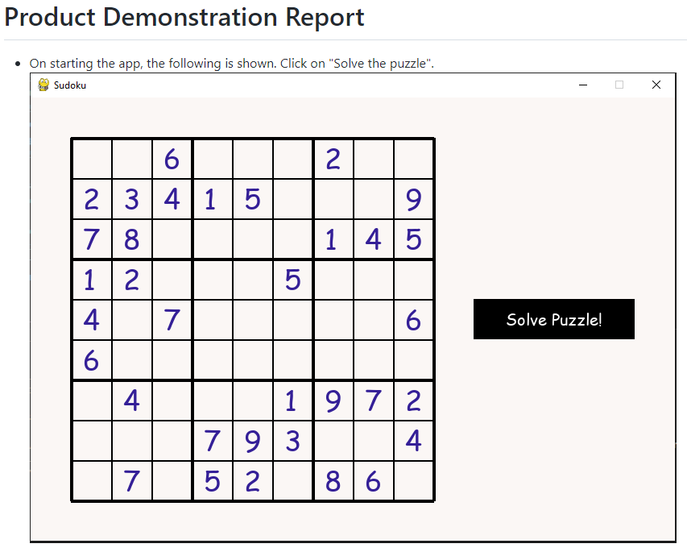

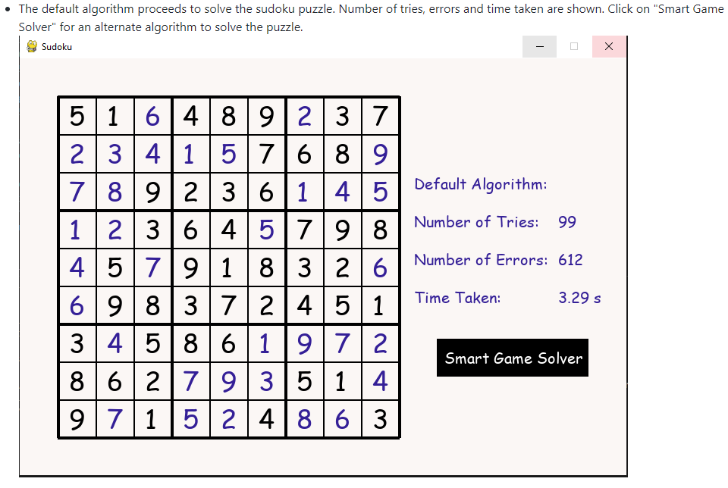

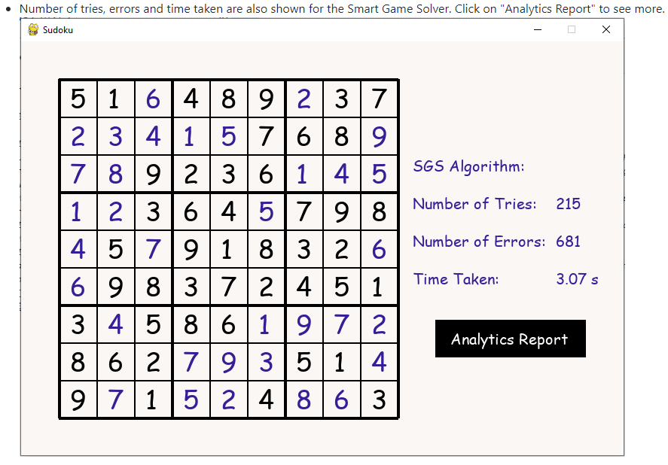

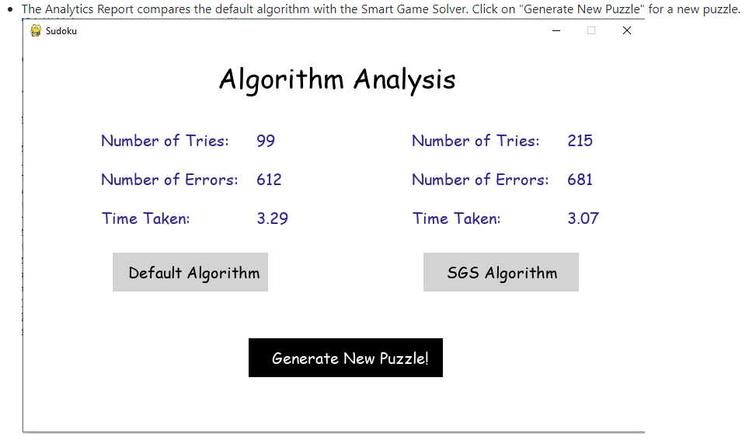

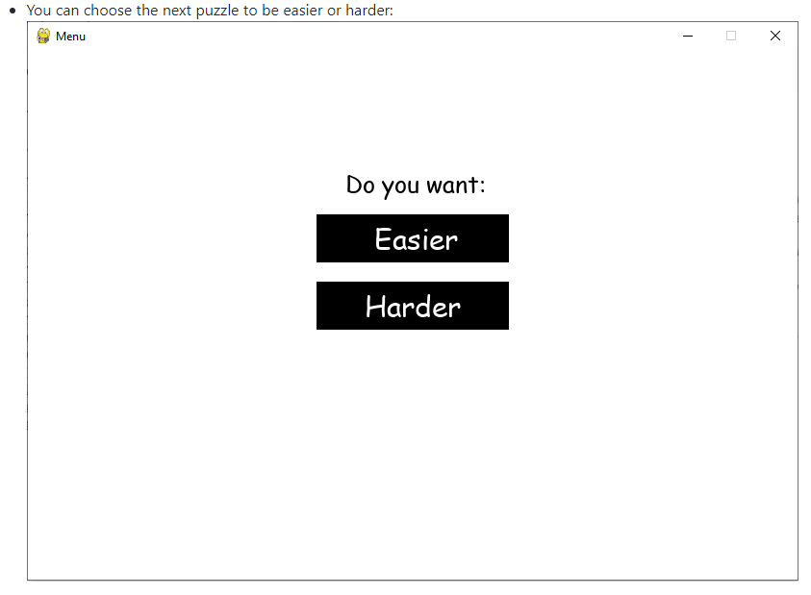

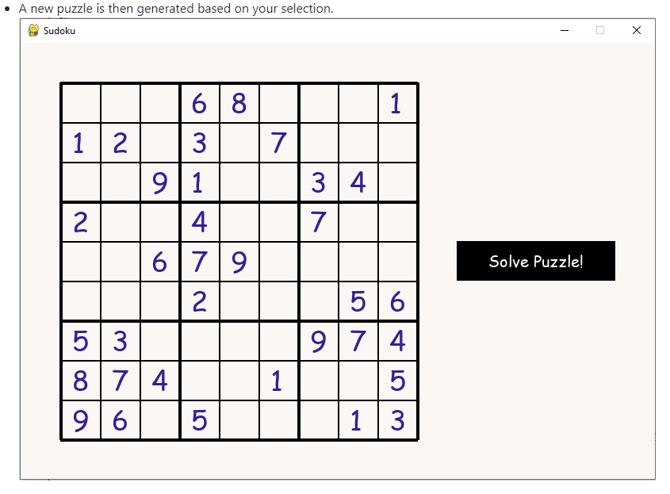

# MVP Requirements and Risk Log

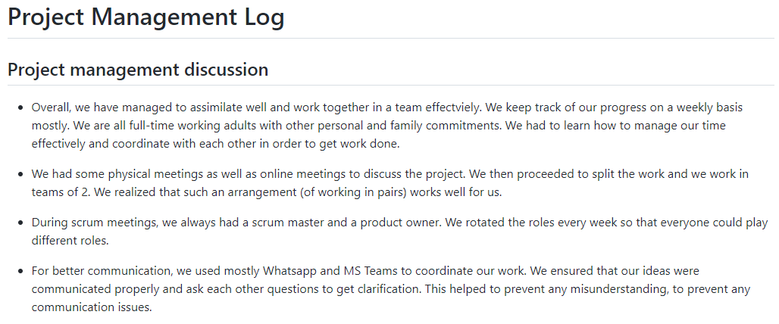

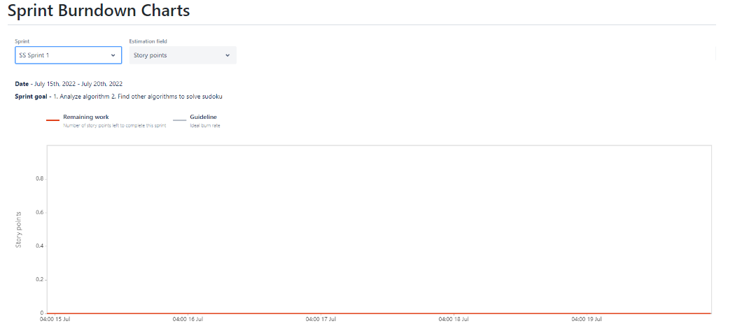

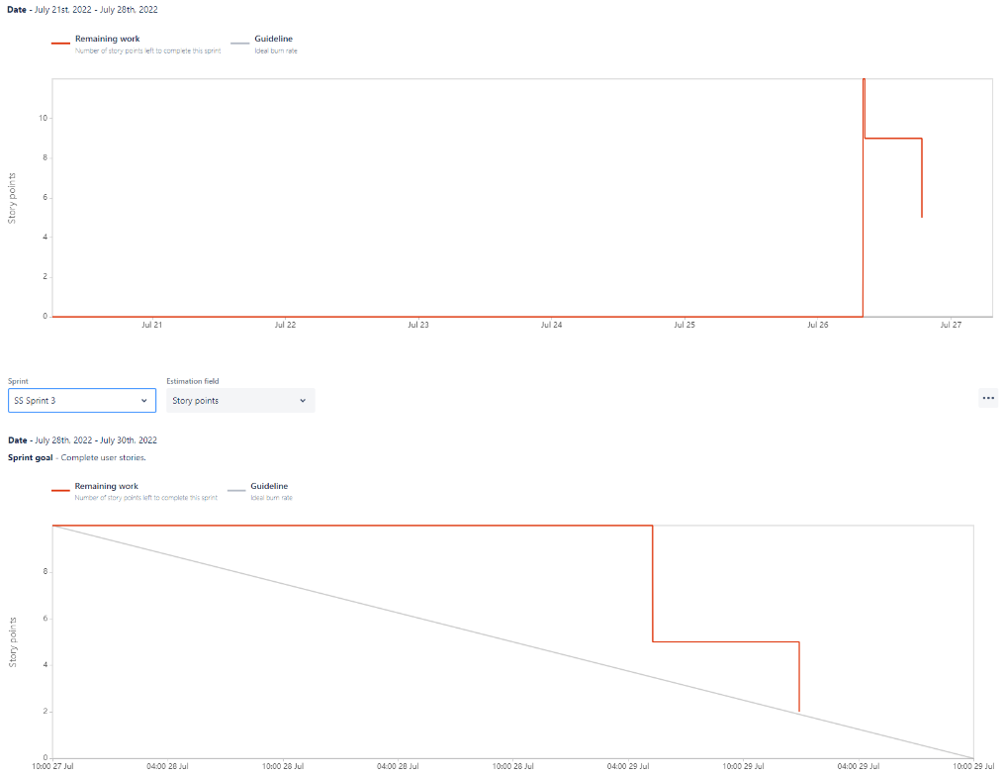

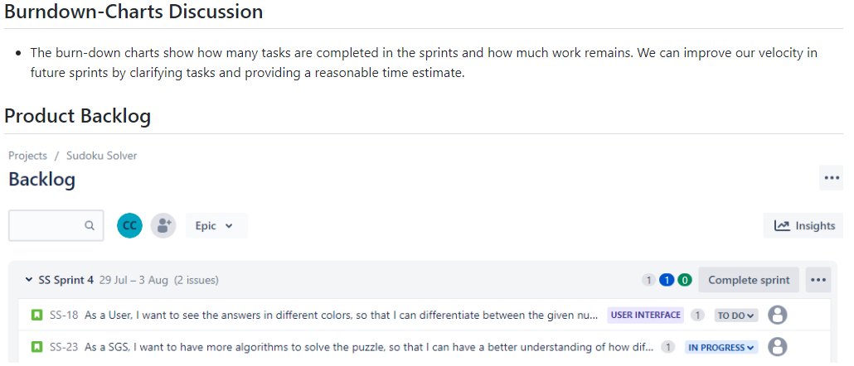

1. MVP Project Management Log

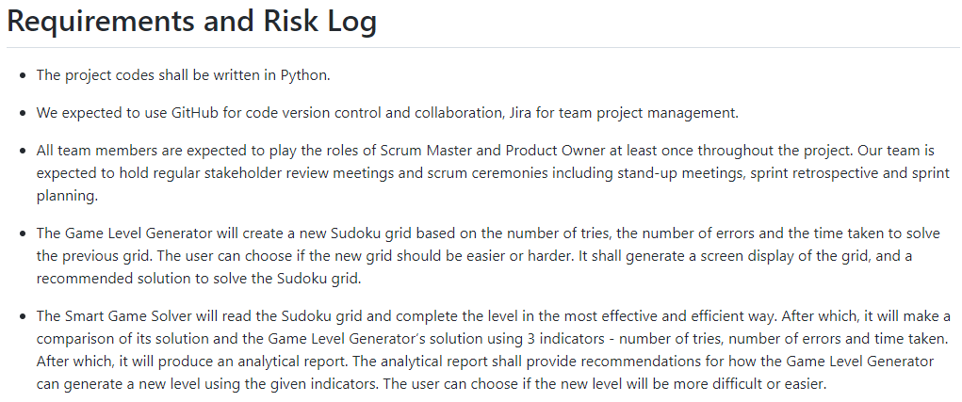

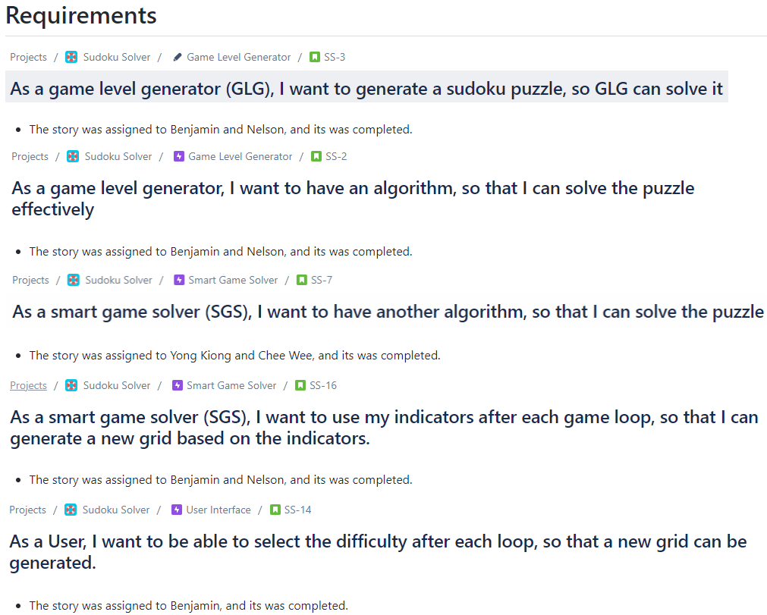

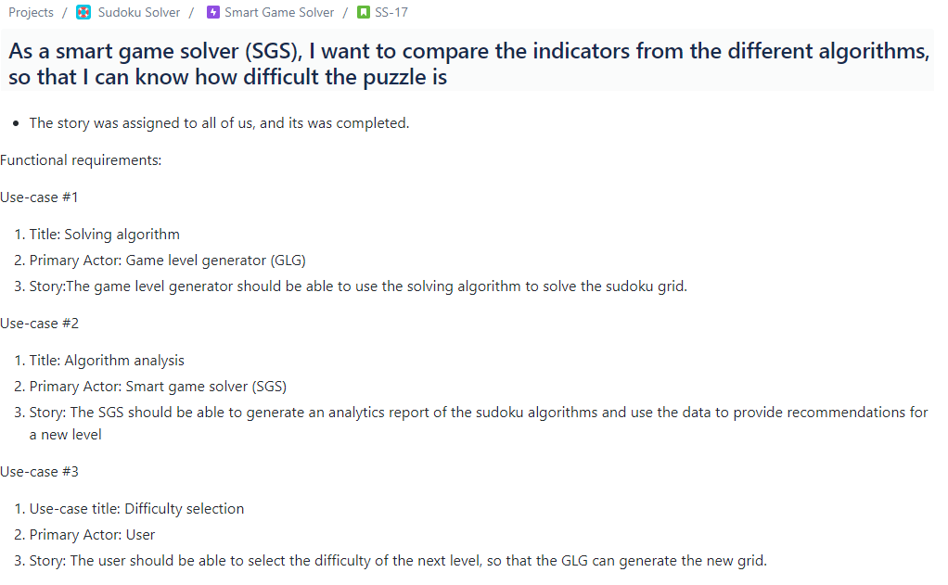

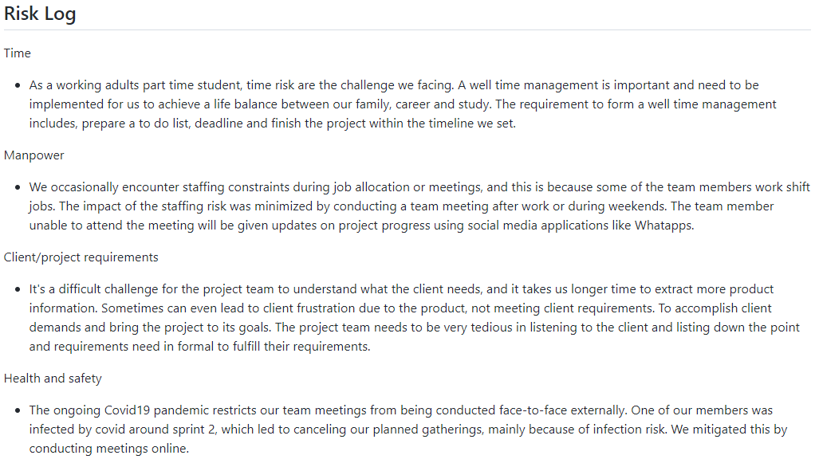

1. MVP Team Effort Log

